Starters
Goat’s Cheese and Caramelised Onion Tart
Served with pickled beetroot and dressed leaves £6.95

Soup of the Day
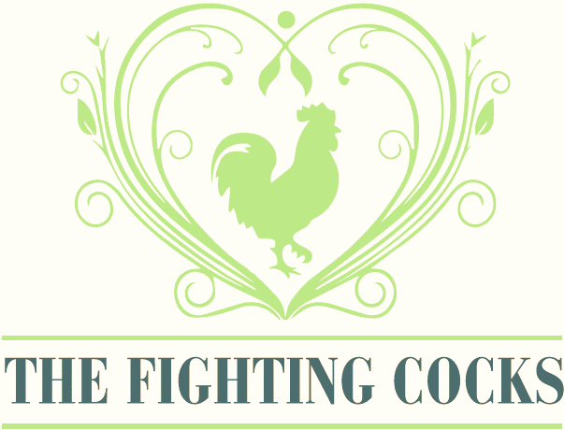
Served with warm bread and butter £4.50

BBQ Chicken Wings
Served with a garlic mayonnaise dip
5 wings £6.00 10 wings£9.50

Homemade Fish Cakes
Smoked coley and haddock fishcakes with spinach and cheddar served with a tartare sauce
£6.50

Homemade Scotch Egg
Pork and chorizo sausage meat wrapped around a free-range egg, served with paprika mayonnaise and baby leaves £6.50

Lemon & Chickpea Fritters (Vegan)
With vegan lemon & garlic mayo £4.95

