Starters
Soup of the Day
Served with warm bread and butter
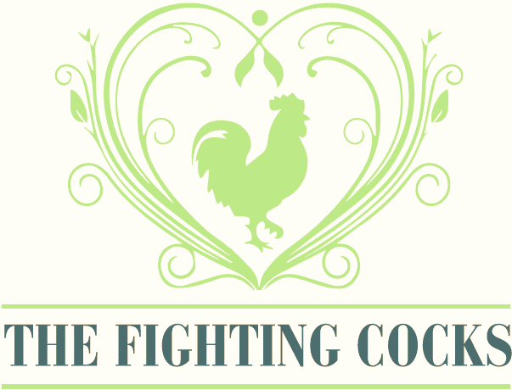
£4.50
Roasted Stilton and Portobello Mushroom
With a bread crumb topping
served with a dressed leave salad
£6.95
BBQ Chicken Wings
5 wings served with
a garlic mayonnaise dip
£6.00
Homemade Fish Cakes
2 fishcakes served with tartar sauce
£6.50
Homemade Scotch Egg
Pork and chorizo sausage meat wrapped around a free-range egg, served with paprika mayonnaise and a dressed leave salad
£6.50
Ham and Cheese Croquettes
3 croquettes served on bed of dressed salad leaves and garlic mayonnaise
£6.50

