Children’s Menu
Meal Deal
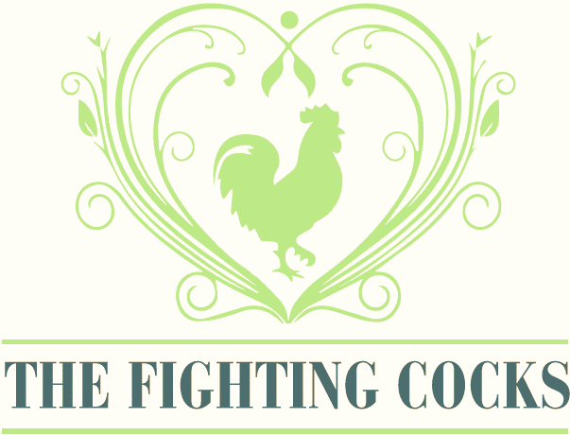
All main meals served with a soft drink & a scoop of vanilla ice cream £7.50

Chicken nuggets
Mac and cheese pasta (V)
Pasta bolognaise
Sausages
Vegan sausages (Vg)
Fish fingers
Fighting Cocks 4oz burger
(with or without cheese)
Served with either fries, mash, chips and one of the following sides: cucumber, carrot sticks, peas, mushy peas or beans

We can provide full allergen information for each dish. Please inform staff if you have any allergies or intolerances.

