Children’s Menu
Meal Deal
All main meals served with a soft drink & a scoop of vanilla ice cream
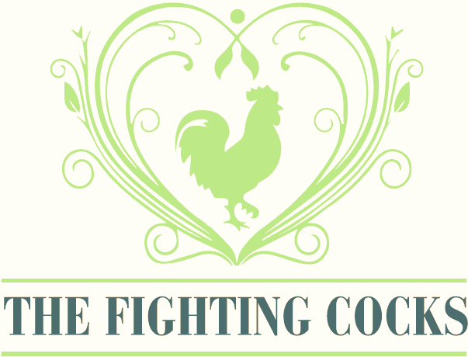
£6.50

Grilled Chicken
Cheese & Tomato Pasta Bake (V)
Chalcroft Farm Chipolatas (3)
Hand breaded fish fingers
Fighting Cocks 4ozburger
Fighting Cocks 4oz cheeseburger

Served with either fries, mash or garlic bread and one of the following sides: cucumber, carrot sticks, peas or beans

Sandwiches
Served with cucumber, carrot sticks or cherry tomatoes
Add fries for £1.25

Marmite Nutella Cheese Ham

£3.50

Or take a look at our small portions on our main menu
We can provide full allergen information for each dish. (V) – vegetarian (GF) – Can be gluten free – please inform staff if you would like your meal made gluten free

