Red Wines
Name | ABV % | Country of Origin | Descriptor | Bottle | 250ml Glass | 175ml Glass | 125ml Glass
Alto Bajo,  Merlot | 13.5% | Chile | Soft and lusciously fruity with blackberry and plum aromas. | £16.95 | £5.95 | £4.60 | £3.40
Finco Valero,  Rioja | 13% | Spain | An easy going red with intense flavour and hints of ripe grapes, and pepper. | £15.95 | £5.50 | £4.25 | £3.10
The Paddock  Shiraz | 13.5% | Australia | Easy drinking & packed with delicious plum and berry flavours. | £15.95 | 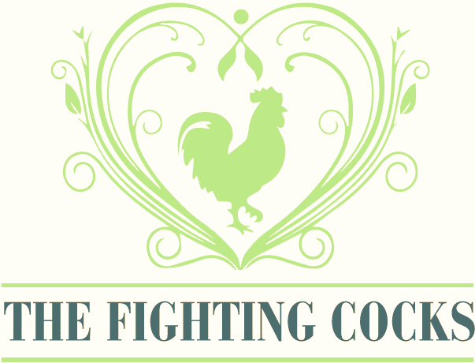  £5.75 | £4.40 | £3.20
Argento,  Malbec | 12.5% | Argentina | A ripe and velvety, tannin red with notes of chocolate. | £19.50 | - | - | -

White Wines
La Maglia Rosa,  Pinot Grigio | 11.5% | Italy | A dry, crisp and light white wine, bursting with peach and citrus fruits with hints of floral tones. | £15.95 | £5.75 | £4.40 | £3.20

Rose Wines
La Maglia Rosa,  Pinot Blush | 11.5% | Italy | A crisp and zesty rose wine with fruity aroma and gentle, floral tones. | £16.95 | £5.95 | £4.60 | £3.40

Sparkling Wines
Prosecco | 10.5% | Italy | Italy’s signature sparkling wine. Crisp, clean and refreshing. | £22.00 | - | - | -
Mini  Prosecco (20cl) | 11% | Italy | A 20cl serving, perfect for a single serving. | £6.90 | - | - | -

The Fighting Cocks Draughts
Name | ABV % | Pint | Half Pint
6X | 4.1% | £3.70 | £1.90
Fosters | 4.0% | £3.90 | £2.00
Birra Moretti | 4.6% | £4.50 | £2.30
Thatcher’s Gold | 4.8% | £3.90 | £2.00
Guinness | 4.2% | £4.20 | £2.10
John Smith’s | 3.6% | £3.80 | £1.90

The Fighting Cocks Bottles
Name | ABV % | Bottle Size | Price
Budweiser | 4.5% | 300ml | £3.90
Peroni |  |  | £4.10
Desperados | 5.9% | 330ml | £4.10
Bulmers Original | 4.5% | 500ml | £4.20
Old Mout Cider | 4.0% | 500ml | £4.40
Heineken 0.0 | 0.0% | 330ml | £3.30
Crabbies | 4.0% | 500ml | £4.20
6X Gold (GF) | 4.5% | 500ml | £4.00

Name  The Fighting Cocks Spirits & Liqueurs | ABV % | Single | Double
Smirnoff Red | 37.5% | £3.20 | £6.30
Gordon’s Gin | 37.5% | £3.20 | £6.30
Bombay Saphhire | 40.0% | £3.20 | £6.30
Gordon’s Pink Gin | 37.5% | £4.20 | £8.30
The Famous Grouse | 40.0% | £3.20 | £6.30
Jack Daniel’s | 40.0% | £3.20 | £6.30
Southern Comfort | 35.0% | £3.20 | £6.30
Jameson | 40.0% | £3.20 | £6.30
Glenfiddch | 40.0% | £4.10 | £8.20
Courvoisier | 40.0% | £3.20 | £6.30
Bacardi | 37.5% | £3.20 | £6.30
Morgan’s Spiced | 35.0% | £3.20 | £6.30
Malibu | 21.0% | £3.20 | £6.30
Mount Gay | 40.0% | £4.00 | £8.00
Pussers Rum | 54.5% | £4.20 | £8.30
Cointreau | 40.0% | £3.10 | £6.10
Bailey’s | 17.0% | - | £3.50
Archer’s | 18.0% | £3.20 | £6.30
Tia Maria | 20.0% | £3.20 | £6.30
Disaronno | 28.0% | £3.20 | £6.30
Drambuie | 40.0% | £3.20 | £6.30
Port | 19.0% | - | £3.30
Pernod | 40.0% | £3.20 | £6.30
Archers | 18.0% | £3.20 | £6.30
Pimm’s | 25.0% | - | £3.30
 | Pint | 16oz | Bottle
Diet Pepsi | £2.50 | £2.00
Pepsi Max | £2.50 | £2.00
Lemonade | £2.50 | £2.00
Appletizer | - | - | £2.50
Ginger Beer | - | - | £2.50
Apple & Raspberry | - | - | £2.50
Orange & Passionfruit | - | - | £2.50
Redbull | - | - | £2.90 *can
Tonic | - | - | £1.50
Slimline Tonic | - | - | £1.50
Bitter Lemon | - | - | £1.90
Tomato Juice | - | - | £1.90
Apple Juice | - | £1.70 | -
Orange Juice | - | £1.70 | -
Pineapple Juice | - | - | £1.90
Ginger Ale | - | - | £1.90
Still Water | - | - | £1.70
Sparkling Water | - | - | £1.70
Cordial | £0.90 | £0.90 | -
Fruit Shoot | - | - | £1.50
Juice and Lemonade | £2.30 | - | -
The Fighting Cocks Soft Drinks

